성 | Surname |  |  | 한글 |  | 성  명 | 남
명 | Given names |  |  |  |  |  | 여
생 년 월 일 |  |  | 국 적 |  | 여권번호
대한민국내 주소 |  |  |  |  | 전화번호
체 류 목 적
성 명 |  |  |  | 漢字 |  | 성  별 | 남
 |  |  |  |  |  |  | 여
여 권 번 호 또 는  주 민 등 록 번 호 |  |  | 국 적
 |  |  | 전화번호
주 소
근 무 처
피보증외국인과 관계 |  |  | 직 위
근 무 처 |  |  | 비 고

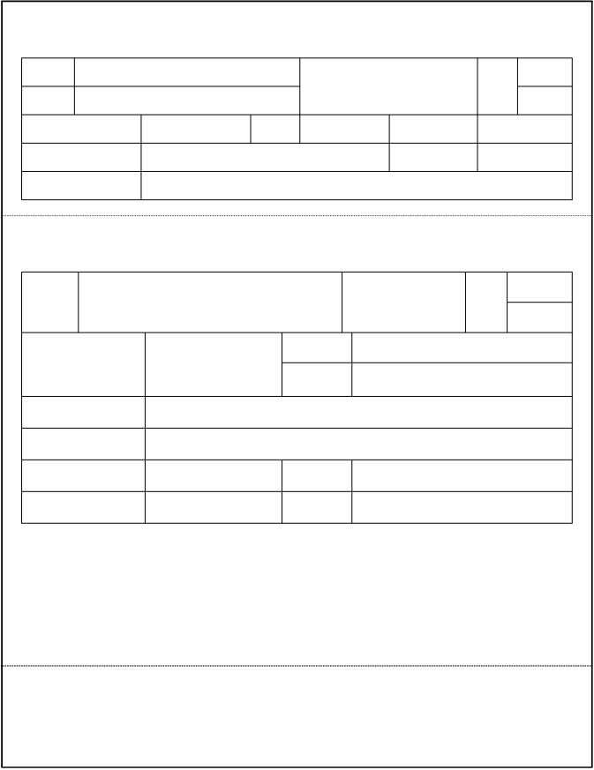신
원
보
증
서

2. 신원보증인
1. 피보증외국인

나. 보증기간
가. 인적사항

.
.
부터
20
.
.
까지(1년)

다. 보증내용
(1) 체류중 제반법규를 준수하도록 한다.
(2) 출국여비 및 이와 관련된 모든 비용에 대한 지불책임을 부담한다.
(3) 체류 또는 보호중 발생되는 모든 비용에 대한 지불책임을 부담한다.

위 신원보증인은 피보증외국인이 대한민국에 체류함에 있어서 그 신원에 이상이 없음을 확인하고
위 사항을 보증합니다.

20
년
월
일

23236-08721일
99. 1. 22. 승인
신원보증인(서명 또는 인)

210㎜×297㎜
(일반용지 60g/㎡)

